http://linuxdrops.com/install-the-coolest-of-all-analogi-ossec-web-user-interface-on-centos-rhel-debian-ubuntu/

Install The Coolest Of All AnaLogi OSSEC Web User Interface On CentOS, RHEL, Debian, Ubuntu
Security 18
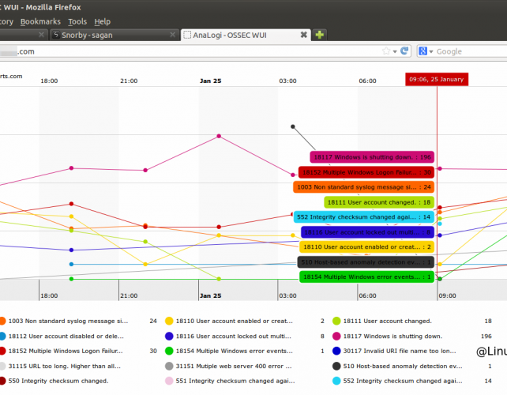

Overview
OSSEC is a great IDS tool but you would agree that the alerts needs to be presented in a nice and cleaner way, however the default ossecwui just does not cut it. Some other IDS systems like snort andsagan have some of the very nice looking interfaces like snorby. Many system administrators struggle with ossec as the default interface is not very informative and is dead plain simple. Luckily someone thought about it and came up with AnaLogi, thanks to Andy the guy behind the project.

Install the coolest of all AnaLogi OSSEC web user interface on CentOS, RHEL, Debian, Ubuntu
First to use AnaLogi the alerts need to be pushed to a database instead of ossec just writing them to a file. This step is very simple, even if you have a working setup or is just starting a fresh install, first you have to decide the type of database you gonna use. Currently ossec supports mysql and postgresql. This post assumes you will use mysql, for postgresql just install postgersql libraries and database packages instead of mysql.
On Debian, Ubuntu system

$ sudo su -
# apt-get install mysql-server build-essential libmysqlclient15-dev
On CentOS/RHEL, Fedora

# yum install mysql-devel mysql-server mysql gcc gcc-c++ autoconf automake
Download and prepare the source for db logging

# wget http://www.ossec.net/files/ossec-hids-2.7.tar.gz
# tar -zxvf ossec-hids-2.7.tar.gz
# cd ossec-hids-2.7/src
# make setdb
# cd ..
Create a new database to save ossec alerts and create a schema for it using the schema file included with the installer.

# mysql -u root -p
mysql> create database ossec;
mysql> grant all privileges on ossec.* to ossecuser identified by ossec@123;
mysql> flush privileges;
mysql> quit
# mysql -u root -p ossec < ossec-hids-2.7/src/os_dbd/mysql.schema
Execute install.sh. If ossec is already running, the script will update the binaries. The script will not change any of the settings made by you in the local conf files, however always take a backup of the ossec directory before continuing.

# ./install.sh
Next enable the database daemon and restart ossec for the changes to take effect.

# /var/ossec/bin/ossec-control enable database
# /var/ossec/bin/ossec-control restart
Download AnaLogi wui for ossec.

# cd /var/www/
# wget https://github.com/downloads/ECSC/analogi/AnaLogi_v1.3.zip
# unzip AnaLogi_v1.3.zip
# mv ECSC-analogi-a1cd5e3 ossecui
On CentOS, RHEL

# chown apache.apache ossecui
On Debian or Ubuntu

# chown www-data.www-data ossecui
Open the db_ossec.php file

# vi /var/www/ossecui/db_ossec.php
Add the database name, user name and password created above for ossec

define ('DB_USER_O', 'ossecuser');
define ('DB_PASSWORD_O', 'ossec@123');
define ('DB_HOST_O', '127.0.0.1');
define ('DB_NAME_O', 'ossec');
Create a vhost entry
On RHEL, CentOS

# vi /etc/httpd/conf/httpd.conf
On Debian, Ubuntu

# vi /etc/apache2/sites-enabled/000-default
Append the following to it

<VirtualHost *:80>
ServerAdmin admin@linuxdrops.com
DocumentRoot /var/www/ossecui
ServerName ossec.linuxdrops.com
ErrorLog logs/ossec-err-error_log
CustomLog logs/ossec-access-access_log common
<Directory /var/www/ossecui>
Allow from all
Options -MultiViews
</Directory>
</VirtualHost>
Restart apache
On Debian, Ubuntu

# /etc/init.d/apache2 restart
On RHEL, CentOS

# /etc/init.d/httpd restart
Point you browser to
http://ipaddress-or-domainname
Some of the screenshot below.
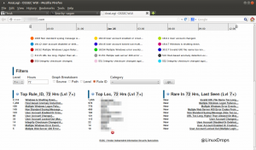
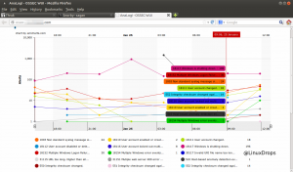

http://nolabnoparty.com/en/setup-ossec-with-mysql-and-analogi-in-centos-6/

OSSEC is an open source host-based intrusion detection system that performs log analysis, file integrity checking, policy monitoring, rootkit detection.
Running on different systems (Windows, Linux, MAC, …), collected data can be stored in a mySQL database and some reports can be displayed using the web gui AnaLogi.

Prerequisites
Starting from the CentOS 6.4 minimal installation, this procedure relies on three main packages:
  - mySQL v5.x database
  - OSSEC v2.7 log analyzer
  - AnaLogi v1.3 ossec-wui

Install mySQL
Update the system and install mySQL packages and compilers.
# yum update
# yum install mysql-devel mysql-server gcc make
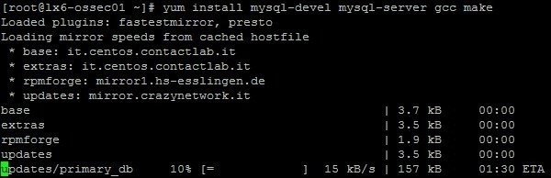
To work properly, SELINUX must be disabled.
# vi /etc/selinux/config
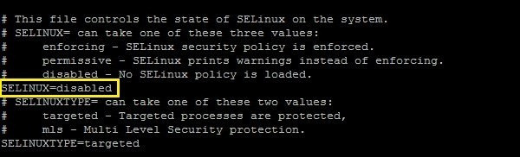
Enable mySQL to start during system boot and start the service.
# chkconfig mysqld on
# service mysqld start
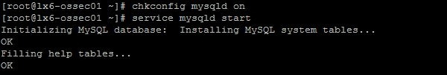
Secure mySQL running the following command.
# /usr/bin/mysql_secure_installation
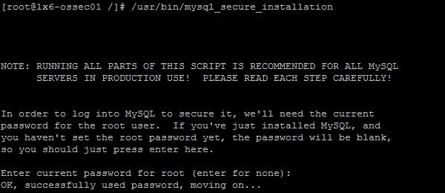

Install Ossec and create mySQL db
Using the command wget, download the OSSEC package and decompress the file.
# wget http://www.ossec.net/files/ossec-hids-2.7.tar.gz
# tar -vxzf ossec-hids-2.7.tar.gz
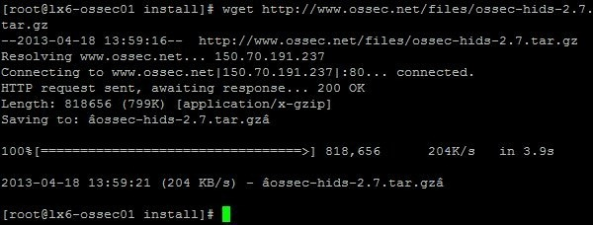
Because by default is disabled, enable mySQL in OSSEC.
# cd ossec-hids-2.7/src
# make setdb
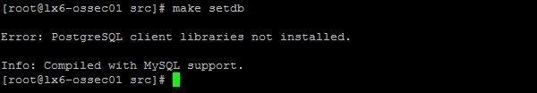
Create a new mySQL database to save OSSEC alerts.
# mysql -u root -p
mysql> create database ossec;
mysql> grant INSERT,SELECT,UPDATE,CREATE,DELETE,EXECUTE on ossec.* to ossec@localhost;
mysql> set password for ossec@localhost=PASSWORD(‘password’);
mysql> flush privileges;
mysql> quit
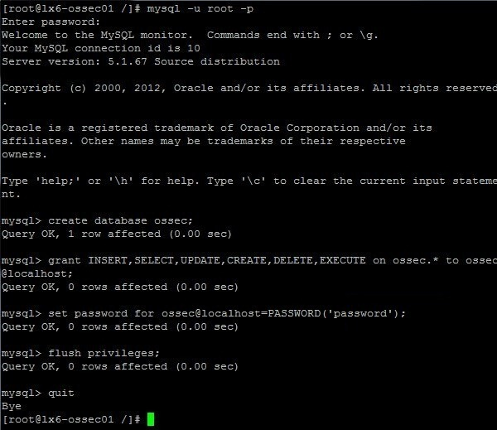
Import the schema for the new database from the OSSEC installation directory ossec-hids-2.7/src/os_dbd/.
# cd ossec-hids-2.7/src/os_dbd
# mysql -u root -p ossec < mysql.schema
Now proceed with OSSEC installation executing the file install.sh.
# ./install.sh
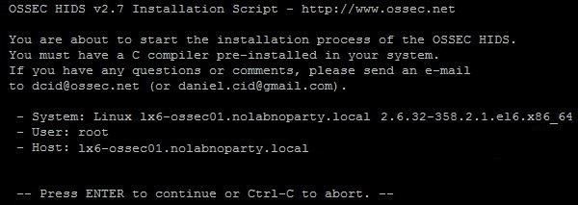
Hit the ENTER button to start the configuration process.
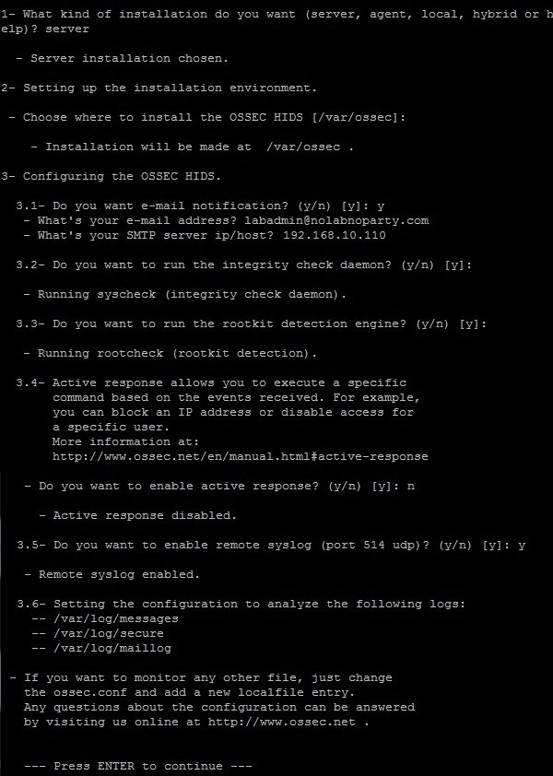
After pressing ENTER, system compiles and install OSSEC in the computer.
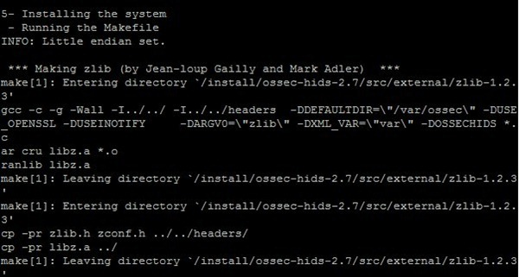
If everything goes smoothly, the installation finishes without any warning or error.
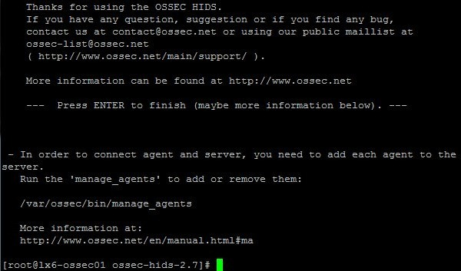
If OSSEC works behind a firewall, the communication with the agent occurs through port UDP 1454.
It’s now time to set the mySQL parameters in the OSSEC configuration. Edit the file ossec.conf.
# vi /var/ossec/etc/ossec.conf
Add the following lines:
1  2  3  4  5  6  7 | <database_output>  <hostname>127.0.0.1</hostname>  <username>ossec</username>  <password>password</password>  <database>ossec</database>  <type>mysql</type>  </database_output>
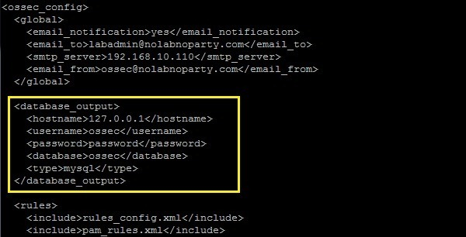
Last step, enable mySQL and restart the service.
# /var/ossec/bin/ossec-control enable database
# /var/ossec/bin/ossec-control restart
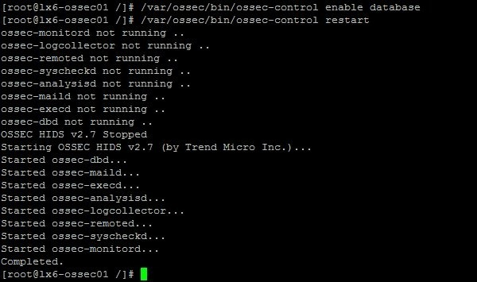

Install AnaLogi web interface
Because AnaLogi is a web interface for OSSEC that replaced the outdated ossec-wui, we need toinstall Apache and PHP in our system.
# yum install httpd php php-mysql mod_ssl
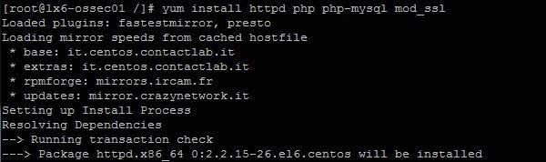
Enable Apache to start during system boot and start the service.
# chkconfig httpd on
# service httpd restart
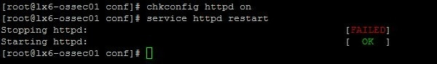
Because AnaLogi is stored using git repository, we need to install the git package to retrieve the files from the website.
# yum install git-core
Once installed git, download the AnaLogi package using git clone command.
# cd /var/www/html
# git clone https://github.com/ECSC/analogi.git
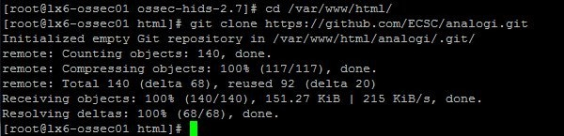
Assign ownership of AnaLogi directory to user apache.
# chown apache:apache analogi -R
Rename the configuration file.
# cd /var/www/html/analogi
# mv db_ossec.php.new db_ossec.php
Edit the db_ossec.php file and amend the SQL parameters to reflect your installation.
# vi db_ossec.php

If you want creating a virtual host, edit the Apache configuration file and add the following lines:
# vi /etc/httpd/conf/httpd.conf
1  2  3  4  5  6  7  8  9  10  11  12 | <VirtualHost *:80>  ServerAdmin admin@nolabnoparty.local  DocumentRoot /var/www/html/analogi  ServerName lx6-ossec01.nolabnoparty.local  ErrorLog logs/ossec-err-error_log  CustomLog logs/ossec-access-access_log common  <Directory /var/www/html/analogi>  Allow from all  Options -MultiViews  </Directory>  </VirtualHost>
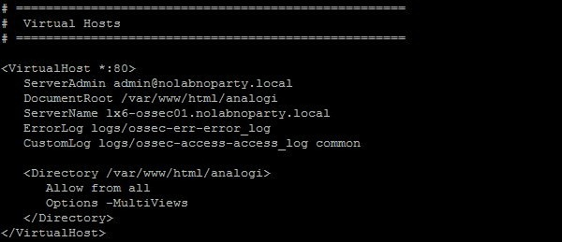
Restart Apache.
# service httpd restart
Open your browser and type the URL address:
http://ip_address
https://ip_address/analogi
If you can see a similar screen, OSSEC server is working properly.
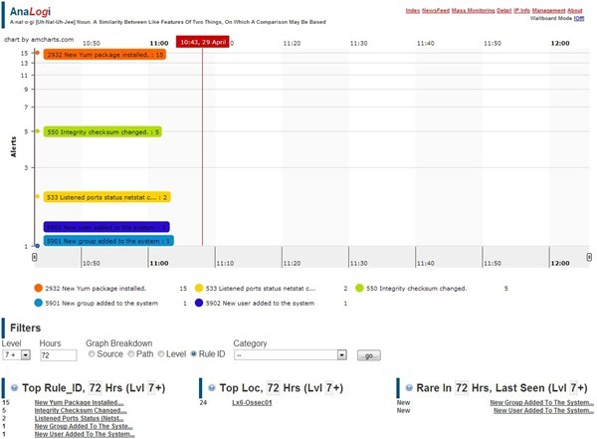

The OSSEC server is now fully functional, last step to perform is the creation of agents for your clients.

